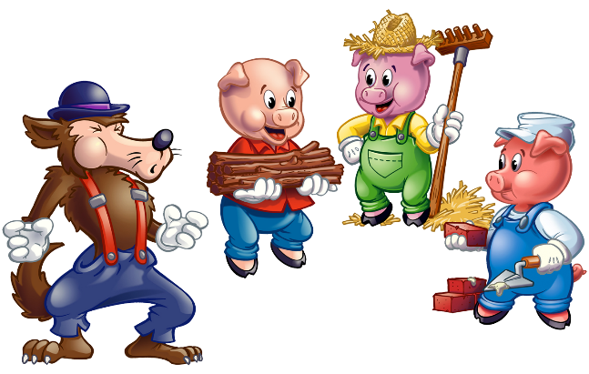
Mixed grammar practise Unit 4
Fill in the correct form of the adjective (bijvoeglijk naamwoord) or adverb (bijwoord).
- Once upon a time there were three little pigs who wanted to see the world. When the they left home, their mum gave them some advice: Whatever you do, do it the (good) ___________ you can.
- So the three pigs wandered through the world and were the (happy) ___________ pigs you've ever seen.
- They were playing (funny) ___________ games all summer long, but then came autumn and each pig wanted to build a house.
- The first pig was not only the (small) ___________ but also the (lazy) ___________ of the pigs.
- He (quick) ___________ built a house out of straw.
- The second pig made his house out of wood which was a bit (difficult) ___________ than building a straw house.
- The third pig followed his mum's advice and built a strong house out of bricks, which was the (difficult) ___________ house to build.
- The pig worked very (hard) ___________ , but finally got his house ready before winter.
- During the cold winter months, the three little pigs lived (extreme) ___________ (good) ___________ in their houses.
- They (regular) ___________ visited one another and had the (wonderful) ___________ time of their lives.

Tenses
Present Simple or Present Continuous
- Maria (want) ___________ to improve her English.
- Therefore, she (do) ___________ a language course in London at the moment.
- She (stay) ___________ with a host family and (must) ___________ take the tube to get to her language school.
- It (be) ___________ only a five-minute walk to the nearest tube station.
- The tube (leave) ___________ at half past eight.
- The first lesson (begin) ___________ at 9 o'clock.
- In the afternoons, the school (offer) ___________ sightseeing tours in and around London.
- Tomorrow, the students of the language school (go) ___________ to Windsor.

Past Simple or Past Continuous
- When I (get) ___________ up yesterday, the sun (shine) ___________.
- It (is) ___________ a beautiful morning.
- So I (decide) ___________ to cycle around a little.
- I (go) ___________ to the shed and (take) ___________ out my bike.
- While I (cycle) ___________ past some villages, I (see) ___________ some people in their gardens.
- One man (mow) ___________ the grass while his wife (pick) ___________ strawberries.
- After one hour of cycling in sunshine, a big fat raincloud suddenly (appear) ___________ and it (start) ___________ to rain.
- Luckily, a farmer (notice) ___________ me and (tell) ___________ me to come in.
- While it (rain) ___________ outside, I (sit) ___________ in the farmer's house.
- After a while, the sun (come) ___________ out again.
- I (thank) ___________ the farmer for his hospitality and (move) ___________ on.
Past Simple or Present Perfect

- Last week I (be) ___________ very busy and I (have not) ___________ the time to do a lot in the household.
- On Monday I (work) ___________ three hours overtime and (come) ___________ home very late in the evening.
- From Tuesday to Thursday I (be) ___________ on a business trip.
- On Friday I (go) ___________ to a friend's birthday party and at the weekend I (visit) ___________ my grandparents.
- Tomorrow some friends are coming over. I (see / not) ___________ them for ages and they (be / never) ___________ at my place before.
- I (clean / just) ___________ my house so I can show them around. Now everything is perfect.

